# CS 255 System Design Document Template

This template lays out all the different sections that you need to complete for Project Two. Each section has guidance to prompt your thinking. You will need to continually reference the interview transcript as you work to make sure that you are addressing your client’s needs. There is no required length for the final document. Instead the goal is to complete each section based on what your client’s needs are. Remove this note when you are finished, and replace all bracketed text with the relevant information.

## UML Diagrams

### UML Use Case Diagram

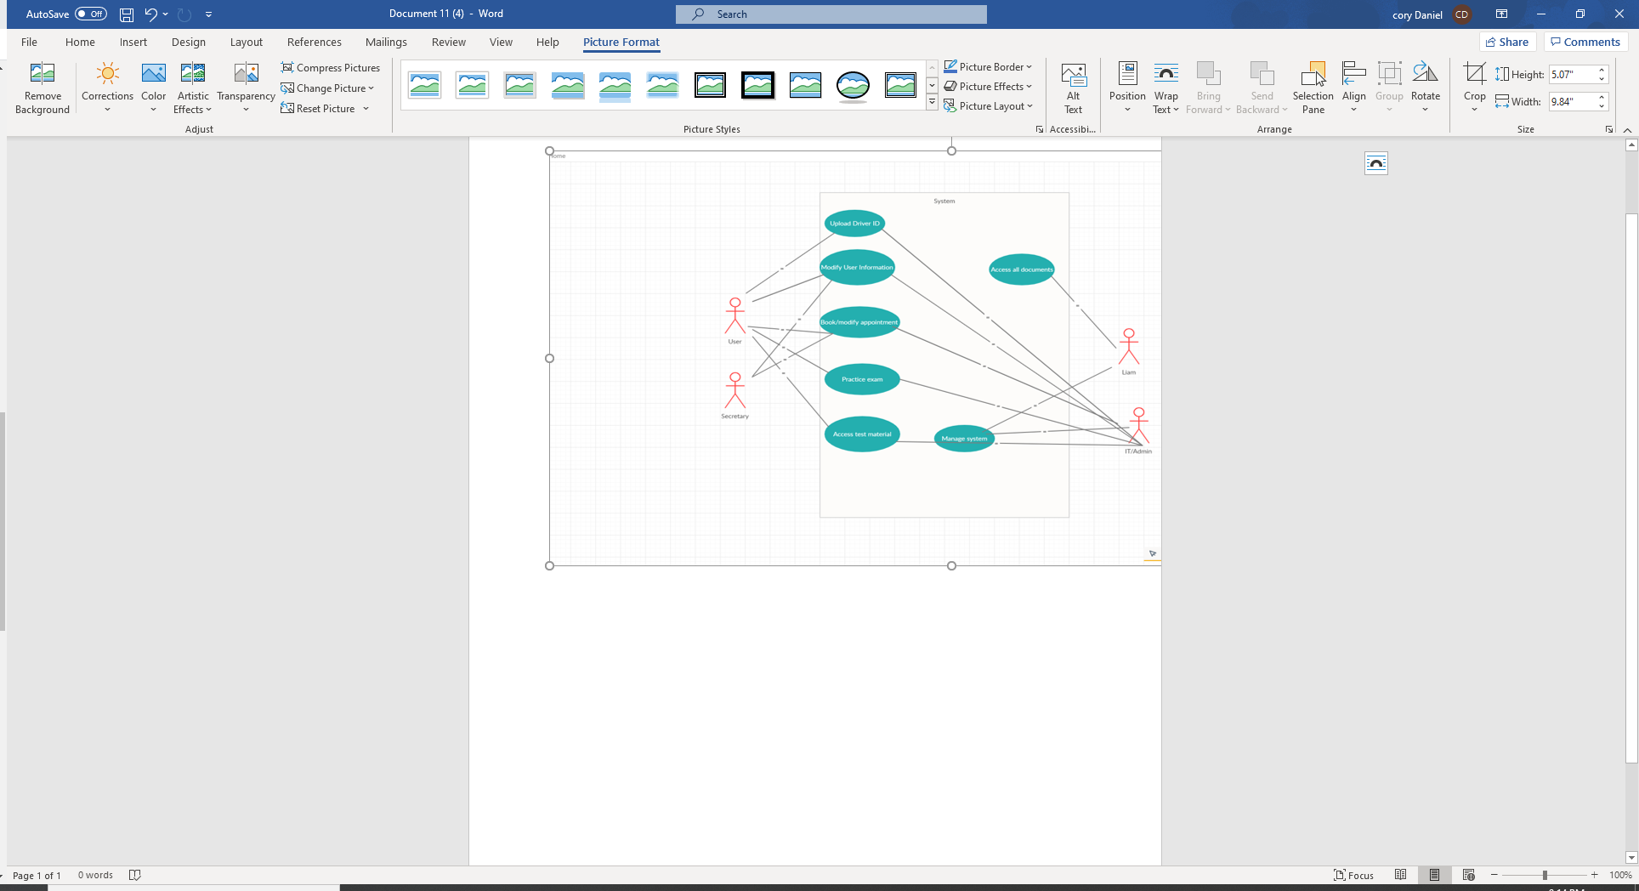

### UML Activity Diagrams

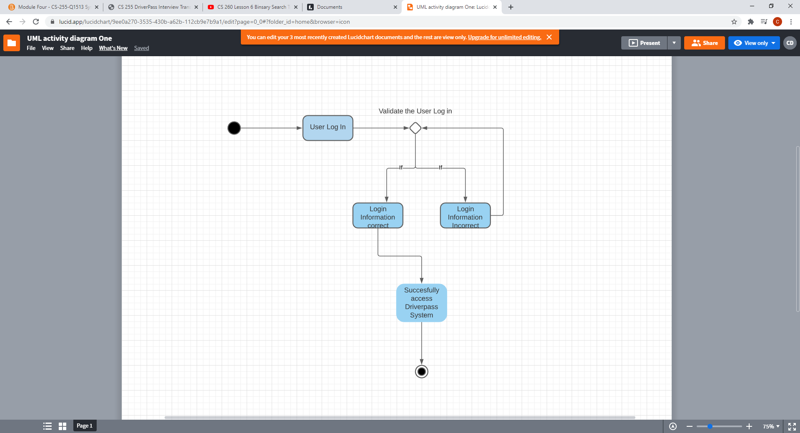

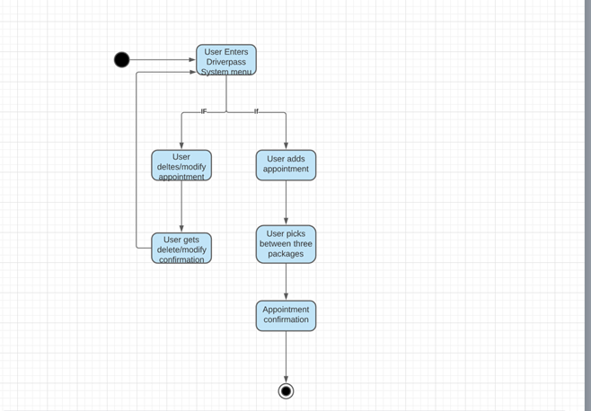

### UML Sequence Diagram

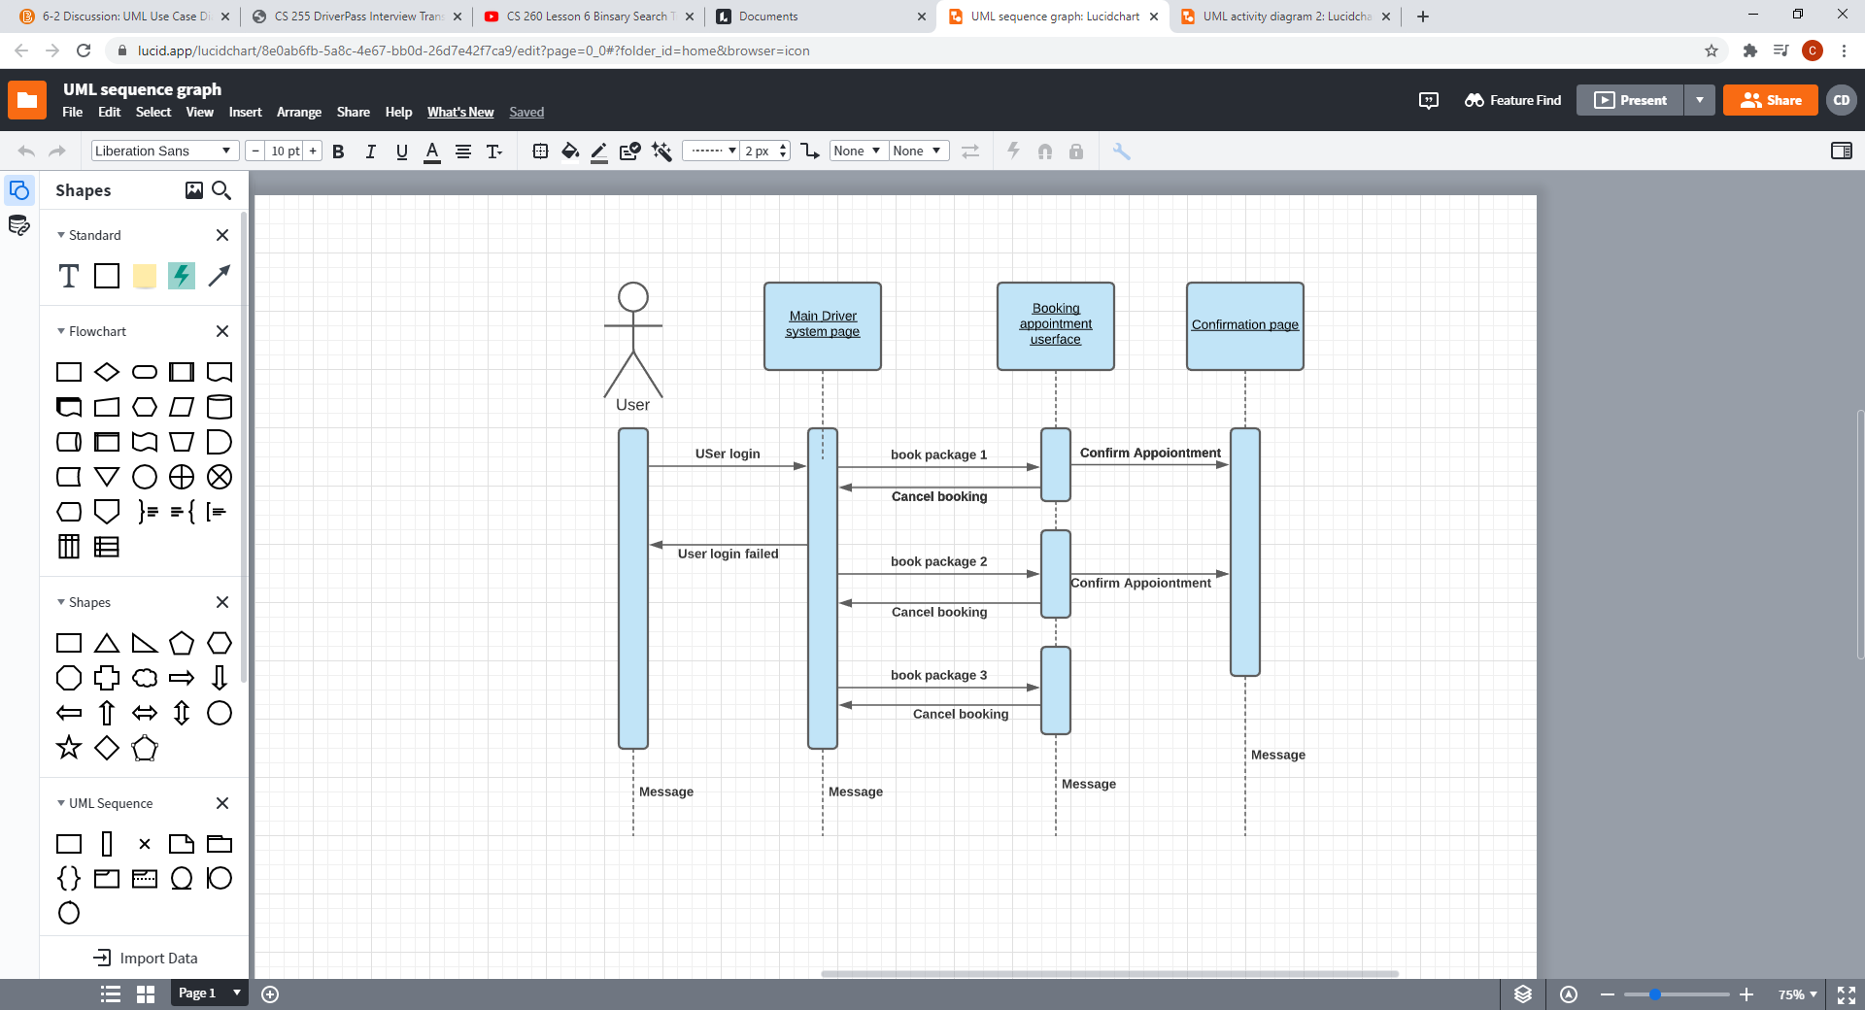

### UML Class Diagram

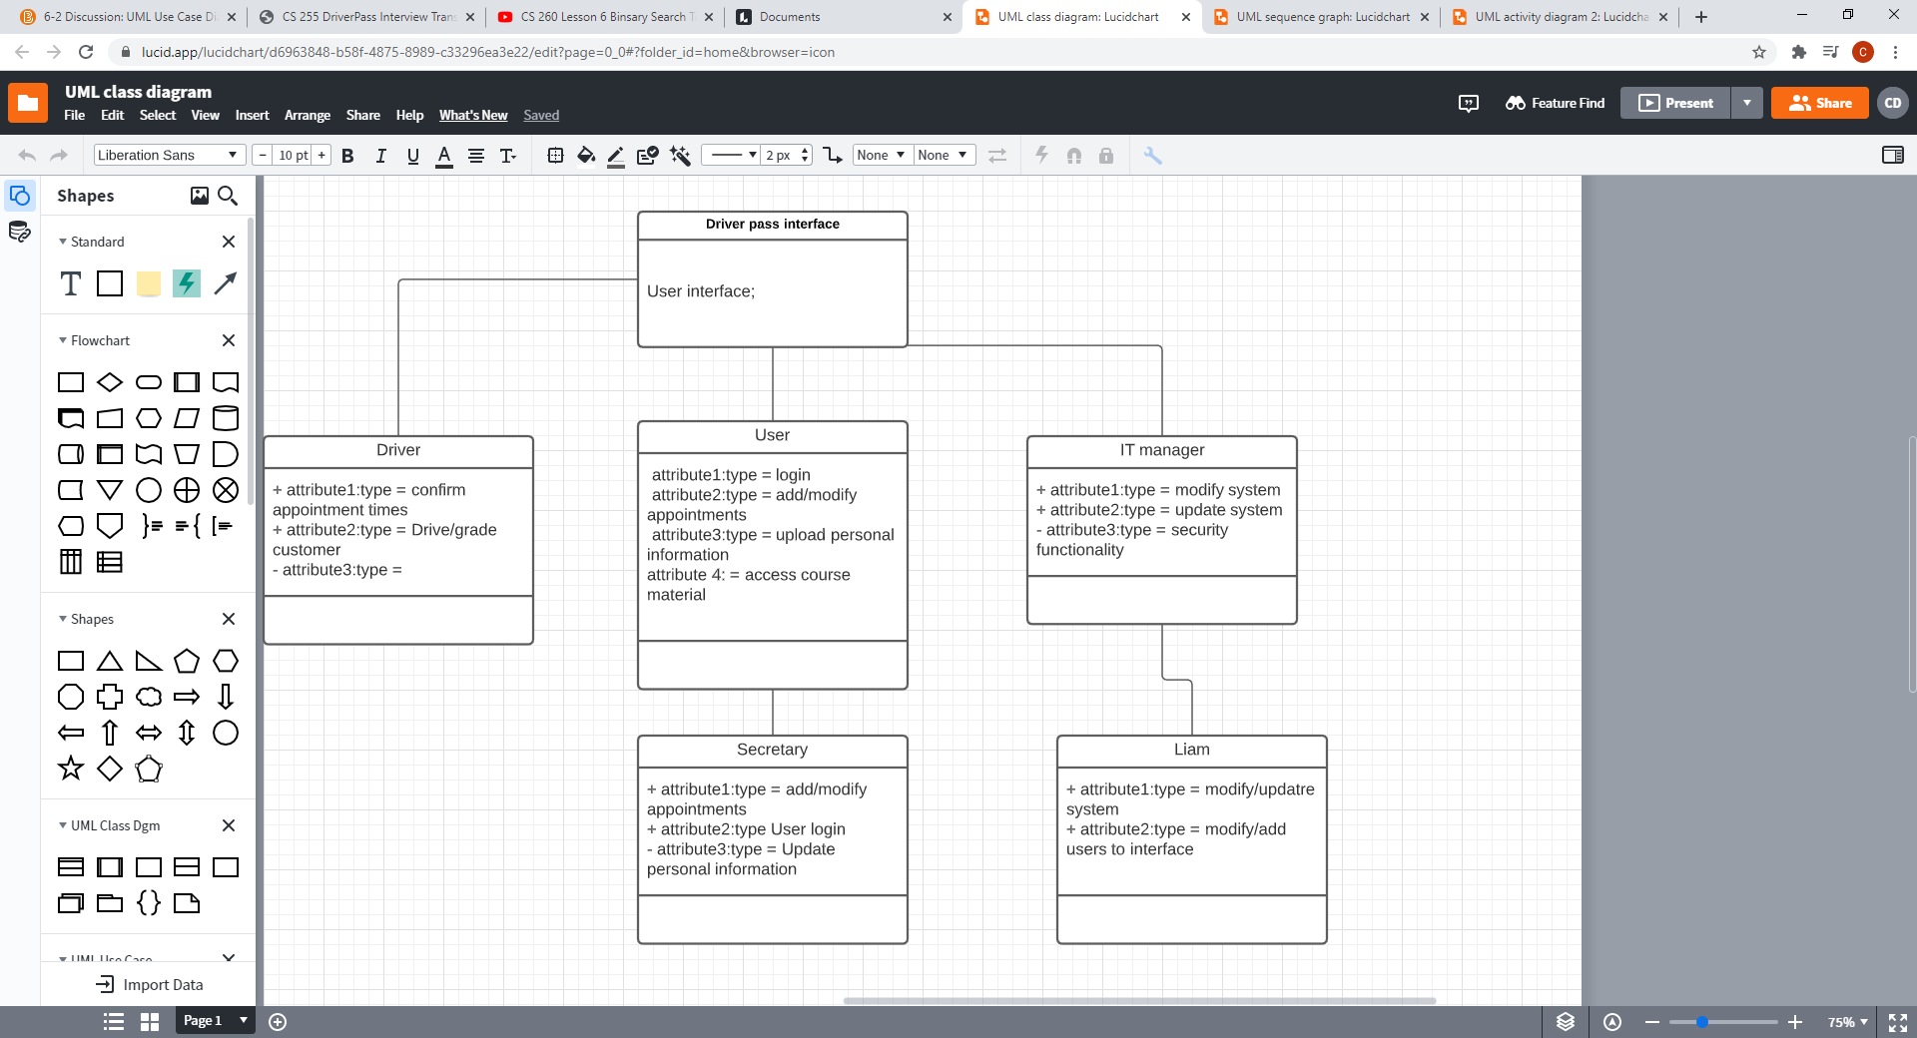

## Technical Requirements

*[Based on the diagrams you have created, describe the technical requirements of your system. These requirements should address the required hardware, software, tools, and infrastructure necessary for your system design.]*

We would need various technical requirements that would be needed for the system, such as sever infrastructure to start. We would need to make sure that we have the adequate servers and databases to run our system smoothly and take care of all the data. We would need various software to run on multiple OS systems and across multiple platforms, so we can engage as many users as possible. The best way would be using cloud bases services as they can operate across multiple platforms and are the future of efficiency when it comes to server infrastructure. We also need to make sure we create an interface that’s user friendly and can run adequately on different types of computing machines, as some users may not have the best hardware to run the software.